Jeroo Final Project

David Seidel

Lab Goal: The goal of this lab is to use concepts learned from Jeroo units 1-4 to solve the maze I have created. It seems easy but you have to be careful not to fall in the water.

Lab Description: This lab requires that you use looping if statements. Your Jeroo must make its way through the maze without falling into the water and stop when reaching the end.

Starting Screen:

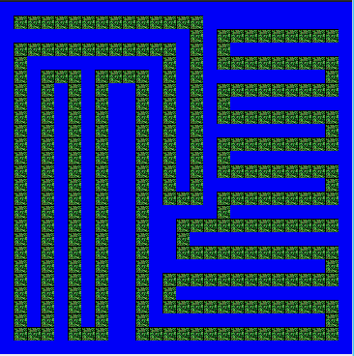

Ending Screen:

